**IMPERIAL COLLEGE OF ENGINEERING**

Boikali, Khulna

Affiliated by Rajshahi University

(Code: 385)

Submitted by,

’ 

 

     

 

 

Assignment no- 01

Submitted to,

Md. Abu Baker Siddik Abir,

Lecturer, ICE

Date: 5th April, 2019

Day: Friday

INDEX:

Contents Page no

1. Name of Experiments 01
2. Objectives of Experiments 02-03
3. Figures of Experiments 04-07
4. Outlines 08-09
5. Applications 10-11
6. List of all apparatus(Names & Ratings) 12

Name of Experiments:

1. Introduction to lab Equipments
2. Verification of Ohm’s Law
3. Verification of series and parallel circuit configuration
4. Experiment on:
   1. Connection of Wattmeter
   2. Identify CC & PC coil
   3. Energy meter and bill calculation
5. Experiment on RLC series circuit configuration

1

Experiments Objectives:

Expt. 1:

1. To know about different electrical meters
2. To know names and uses of meters in circuit lab
3. Advantages and disadvantages of AC and DC
4. Defining electrical and electronics devices

Expt. 2:

1. To be introduced with Ohm’s law
2. To Justify Ohm’s Law
3. To be familiar with different circuit configuration

Expt. 3:

1. To be introduced with series circuit
2. To be introduced with parallel circuit
3. To know about current flow and voltage difference in series and parallel circuit

2

Expt. 4:

1. To understand connection mechanism of Wattmeter.
2. How to identify CC and PC coil in wattmeter
3. How to calculate electric bill and use of energy meter.

Expt. 5:

1. To be introduced with RLC (Resistive, Inductive and Capacitive) Series circuit.
2. To be introduced with impedance
3. Understand relation between impedance and frequency.
4. Know about capacitive and inductive reactance.

3

Experimental Figures:

Experiment 2:

Voltage generator

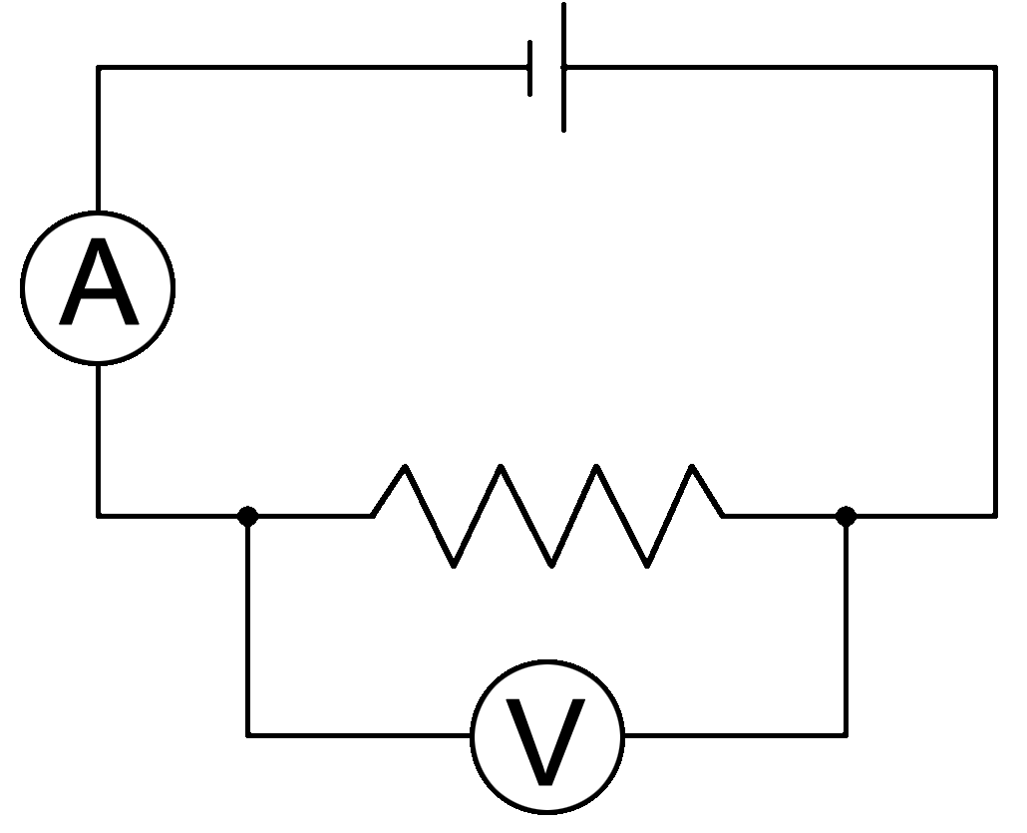

Rheostat

Voltmeter

Ammeter

Figure-1: Voltmeter and ammeter in parallel and series connection respectively with rheostat.

4

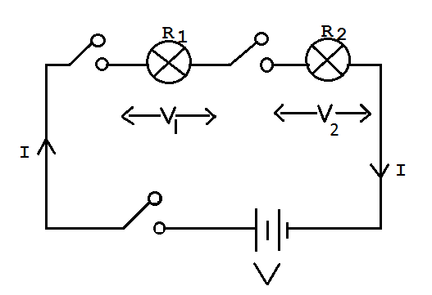Experiment 3:

Figure-2: Two bulbs connected in series

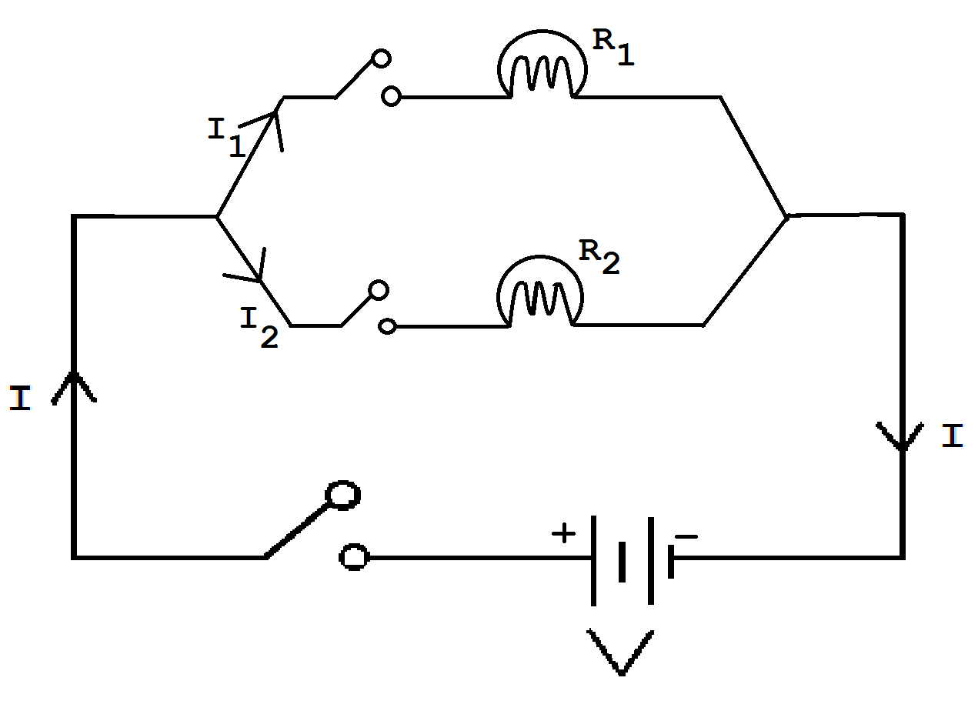

Figure-3: Two bulbs connected in parallel

5

Experiment 4:

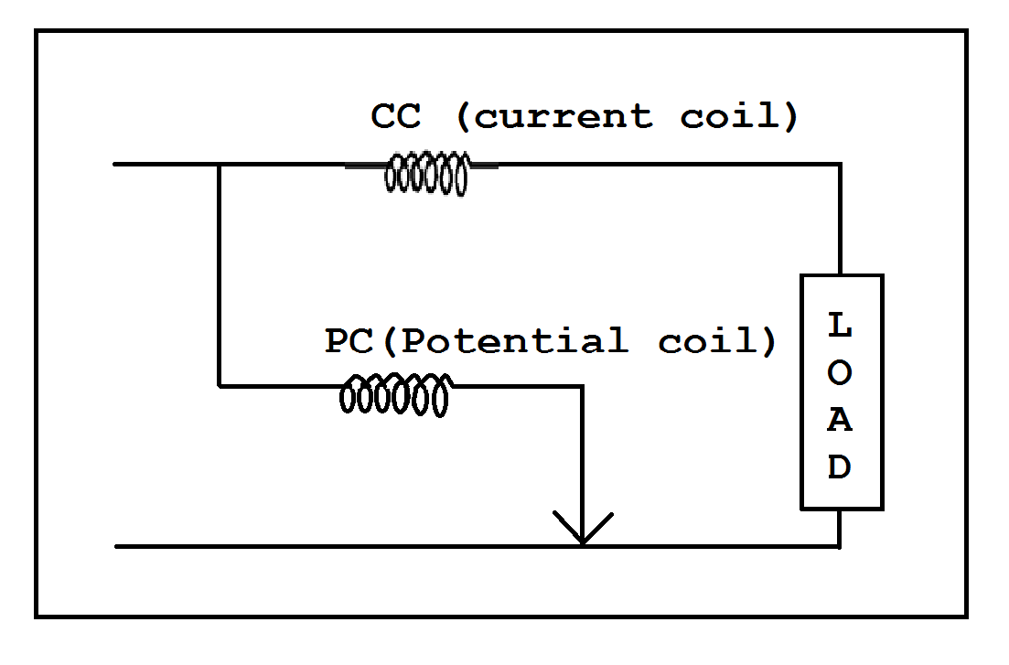

Figure-4: Wattmeter connection diagram

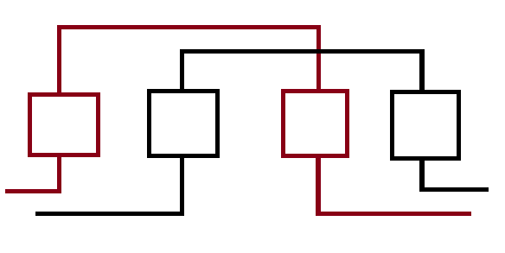

Figure-5: Circuit connection of Energy Meter

6

Experiment 5:

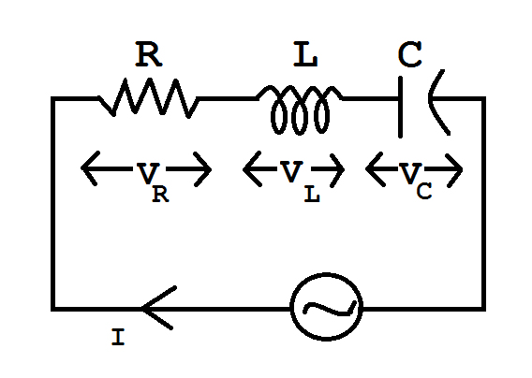

Figure-6: RLC series circuit

7

Outlines

Experiment-1:

1. The meters used in circuit lab are electrical instruments used to measure different units. Examples: current (Amp), voltage (Volt), power (watt), potential.
2. Differentiate between Electrical and Electronics devices.
3. Understand AC and DC advantages and disadvantages.

Experiment-2:

1. Understand Ohm’s Law and draw its graph with equation.
2. Connecting and using Ammeter and Voltmeter in Circuit to measure current and voltage.
3. Supply DC power to circuit and connect the rheostat properly to get current flow.

8

Experiment-3:

1. Familiar with different kinds of circuit: series, parallel and mixed.
2. Examine different elements of circuit.
3. Defining Electrical power and electrical energy.
4. Practical application of voltage and current divider rule.

Experiment-4:

1. Defining power factor with equation.
2. Vector diagram of different loads.
3. Measuring Electric bill.
4. Wattmeter coil identification.

Experiment-5:

1. Understand RLC circuit.
2. Know about impedance.
3. Relation between frequency and impedance,
4. Inductive and capacitive reactance.

9

Application

Experiment-01:

1. Using electrical measuring meters in practical fields.
2. AC and DC connection in practical design.

Experiment-02:

1. Ohm’s law helps us in determining voltage, current or impedance or resistance of a linear electric circuit when the other two quantities are known to us. It also makes power calculation simpler.
2. Ohm’s law makes us realize designing any electronic or electrical circuits without resistor is impossible.

Experiment-03:

1. In designing circuit for and house or office understanding the connection of electrical elements in series, parallel or mixed circuit.

10

Experiment-04:

1. Calculating electric bill and check if the electric meter in giving accurate reading.
2. Power measuring using wattmeter in practical fields

Experiment-05:

1. RLC series connection in circuit.
2. Impedance check and relation of frequency with impedance checking.

11

**Apparatus List**

|  |  |  |
| --- | --- | --- |
| **Serial**  **No.** | **Name** | **Rating** |
|  | Rheostat | (0-100)Ω |
|  | DC Power Supply | (0-30)V |
|  | Flexible wire |  |
|  | Bulb-01 | 100W-220V |
|  | Bulb-02 | 40W- 220V |
|  | Switch(one-way) |  |
|  | Multimeter |  |
|  | Inductive load(Electrical Ballast) |  |
|  | Capacitive load | 2.5μF |
|  | Resistive load(bulb) |  |
|  | Power Meter(Power Source) |  |
|  | Ammeter |  |
|  | Voltmeter |  |

12